CODE ALPHA
DATA SCIENCE INTERNSHIP REPORT
Unemployment in India:
COVID-19 Impact & Regional Analysis

Dataset: Unemployment in India — CMIE (Centre for Monitoring Indian Economy)
Source: https://unemploymentinindia.cmie.com/
Period: May 2019 – June 2020 (14 months)
Coverage: 28 States & Union Territories across India (Rural + Urban)
Records: 768 total rows | 740 clean records (after null removal)
Prepared: June 2026 | Data Science Internship Programme
Peter Okomesi STUDENT ID: CA/DF1/69331

CONFIDENTIAL — INTERNAL USE ONLY

Table of Contents
Table of Contents 1
Executive Summary 1
1. Project Objective 1
1.1 Specific Objectives 1
1.2 Research Questions 1
2. Dataset Description 1
2.1 Dataset Overview 1
2.2 Column Descriptions 1
2.3 Descriptive Statistics 1
3. Data Cleaning & Preprocessing 1
3.1 Cleaning Pipeline 1
Step 1 — Missing Value Detection 1
Step 2 — Row Removal 1
Step 3 — Column Name Standardisation 1
Step 4 — Date Parsing & Conversion 1
Step 5 — Data Type Validation 1
Step 6 — Duplicate Record Check 1
3.2 Final Dataset Summary 1
4. Unemployment Trend Analysis 1
4.1 National Monthly Trend 1
Phase 1 — Pre-COVID Baseline (May 2019 – February 2020) 1
Phase 2 — COVID-19 Shock (March 2020 – May 2020) 1
Phase 3 — Early Recovery (June 2020) 1
4.2 Key Trend Metrics 1
5. Regional Analysis 1
5.1 State-Level Unemployment Rankings 1
5.2 Highest Unemployment States 1
5.3 Lowest Unemployment States 1
5.4 Urban vs Rural Unemployment 1
6. COVID-19 Impact Analysis 1
6.1 COVID-19 Timeline 1
6.2 Phase Comparison 1
6.3 Sectoral Impact Analysis 1
6.4 Recovery Velocity 1
7. Seasonal Trend Analysis 1
7.1 Monthly Seasonal Pattern 1
7.2 Monthly Breakdown 1
7.3 Seasonal Observations 1
8. Labour Force Participation Rate Analysis 1
8.1 National LFPR Overview 1
8.2 State-Level LFPR 1
8.3 The Labour Participation Paradox 1
9. Key Insights 1
Insight 1: COVID-19 Caused a Historic, Unprecedented Labour Market Shock 1
Insight 2: Geographic Concentration of Vulnerability 1
Insight 3: Urban-Rural Divide in Vulnerability and Recovery 1
Insight 4: India's Informal Sector as Economic Shock Absorber 1
Insight 5: The Labour Participation Paradox Signals Structural Issues 1
Insight 6: Seasonal Stability Provides a Reliable Policy Benchmark 1
10. Policy Recommendations 1
Recommendation 1: State-Targeted Economic Stimulus 1
Recommendation 2: Urban Safety Net Expansion 1
Recommendation 3: Labour Force Participation Enhancement for Women 1
Recommendation 4: Strengthening Rural Employment Buffers 1
Recommendation 5: Real-Time Labour Market Monitoring Infrastructure 1
Recommendation 6: Crisis Employment Preparedness Framework 1
11. Conclusion 1
Appendix A: Complete Regional Unemployment Data 1
Appendix B: Data Cleaning Python Code 1

Executive Summary
This report presents a comprehensive data science analysis of unemployment trends across India, with a focused examination of the catastrophic impact of COVID-19 and the subsequent national lockdown on the Indian labour market. The analysis leverages monthly data from the Centre for Monitoring Indian Economy (CMIE) covering 28 states and union territories from May 2019 to June 2020.
Prior to the pandemic, India maintained a relatively stable national unemployment rate hovering around 9.5%. The announcement of a nationwide lockdown on March 24, 2020, triggered an unprecedented labour market shock — unemployment surged to 23.6% in April 2020 and peaked at 24.9% in May 2020, representing a 162% increase over the pre-COVID baseline. The subsequent easing of restrictions in June 2020 resulted in a partial but notable recovery to 11.9%.
Regional analysis reveals stark geographic disparities: Tripura (28.4%), Haryana (26.3%), and Jharkhand (20.6%) recorded the highest average unemployment over the dataset period, while Meghalaya (4.8%), Odisha (5.7%), and Assam (6.4%) remained most resilient. Urban areas consistently registered higher unemployment than rural counterparts (13.2% vs 10.3%), reflecting the disproportionate exposure of urban formal-sector employment to lockdown-induced disruptions.
The analysis concludes with six data-driven policy recommendations targeting geographic priority intervention, urban safety nets, labour force participation enhancement, rural employment buffers, real-time monitoring infrastructure, and crisis preparedness frameworks.

740  Clean Records | 28  States & UTs Covered | 24.9%  Peak Unemployment | +162%  COVID-19 Surge

1.Project Objective
The primary goal of this project is to apply exploratory data analysis (EDA) techniques to a real-world socioeconomic dataset to extract meaningful insights about employment conditions in India and the measurable impact of the COVID-19 pandemic on the Indian labour force.

1.1 Specific Objectives
- Quantify the COVID-19 impact: Measure how India's national lockdown (March–June 2020) spiked unemployment rates across states and sectors, and model the trajectory of the surge and partial recovery.
- Identify regional disparities: Pinpoint which states suffered the highest and lowest unemployment, revealing structural economic vulnerabilities and geographic concentrations of labour market risk.
- Analyse temporal and seasonal trends: Examine month-by-month fluctuations in employment pre- and post-lockdown to identify baseline seasonality and the departure from it during the pandemic period.
- Examine labour force participation: Investigate labour force participation rates (LFPR) alongside unemployment for a more complete picture of workforce engagement across states.
- Compare urban vs rural dynamics: Assess whether the pandemic impacted urban and rural labour markets differently, given their structural and sectoral differences.
- Derive actionable policy recommendations: Translate data insights into evidence-based recommendations for targeted economic recovery and workforce development policy.

1.2 Research Questions
- How did India's COVID-19 lockdown affect the national unemployment rate over time, and how quickly did recovery occur?
- Which states are structurally the most and least vulnerable to unemployment, independent of COVID-19 effects?
- Are there statistically meaningful differences in unemployment between rural and urban areas?
- What seasonal patterns exist in Indian unemployment data, and how does the COVID-19 shock compare to normal seasonal variation?
- What is the relationship between labour force participation rates and unemployment rates at the state level?

2. Dataset Description
The dataset used in this analysis is sourced from the Centre for Monitoring Indian Economy (CMIE), specifically their Unemployment in India tracking platform (https://unemploymentinindia.cmie.com/). CMIE is India's premier independent economic research and business information firm, and its Consumer Pyramids Household Survey — from which this data is derived — is one of the largest ongoing household-level surveys in the world, covering over 170,000 households.

2.1 Dataset Overview

Attribute | Details
Dataset Name | Unemployment in India
Source Organisation | CMIE — Centre for Monitoring Indian Economy
Source URL | https://unemploymentinindia.cmie.com/
Time Period | May 2019 – June 2020 (14 months)
Geographic Coverage | 28 States & Union Territories of India
Measurement Frequency | Monthly
Area Classification | Rural and Urban
Total Raw Records | 768 rows
Clean Records (after processing) | 740 rows
Null/Incomplete Rows Removed | 28 rows

2.2 Column Descriptions
The dataset contains seven columns representing the key dimensions of labour market measurement:

Column Name | Data Type | Description
Region | String | Name of the Indian state or Union Territory being measured
Date | String → DateTime | Month-end date of observation (originally DD-MM-YYYY format)
Frequency | String | Measurement frequency — monthly for all records
Estimated Unemployment Rate (%) | Float64 | Percentage of the labour force that is currently unemployed
Estimated Employed | Float64 | Number of people currently in employment in the region
Estimated Labour Participation Rate (%) | Float64 | Percentage of the eligible population actively participating in the labour force
Area | String | Classification of the observation area: Rural or Urban

2.3 Descriptive Statistics
The following table summarises the descriptive statistics for the three primary numerical variables in the cleaned dataset (n = 740):

Statistic | Unemployment Rate (%) | Estimated Employed | Labour Participation Rate (%)
Count | 740 | 740 | 740
Mean | 11.79% | — | 42.63%
Standard Deviation | 10.72% | — | 8.11%
Minimum | 0.00% | — | 13.33%
25th Percentile | 4.66% | — | 38.06%
Median (50th Percentile) | 8.35% | — | 41.16%
75th Percentile | 15.89% | — | 45.51%
Maximum | 76.74% | — | 72.57%

The maximum unemployment rate of 76.74% recorded for Puducherry represents an extreme local spike during the lockdown period and is an authentic data point — not an error — reflective of the small union territory's economic structure and dependence on tourism and services.

3. Data Cleaning & Preprocessing
Data quality is the foundation of sound analysis. The raw dataset contained 768 records; a systematic cleaning pipeline was applied prior to any analysis, as documented below.

3.1 Cleaning Pipeline

Step 1 — Missing Value Detection
An initial inspection revealed that exactly 28 rows (3.6% of the dataset) contained null values across all seven columns simultaneously. These were systematically empty rows corresponding to unnamed or aggregated records without valid state identifiers, likely artefacts of the data export process. A targeted null-check was performed:

Column | Null Count | % Missing
Region | 28 | 3.65%
Date | 28 | 3.65%
Frequency | 28 | 3.65%
Estimated Unemployment Rate (%) | 28 | 3.65%
Estimated Employed | 28 | 3.65%
Estimated Labour Participation Rate (%) | 28 | 3.65%
Area | 28 | 3.65%

Step 2 — Row Removal
The 28 incomplete rows were dropped in their entirety, retaining 740 clean records (96.4% data retention). No statistical imputation was applied because the null rows represented structurally missing identifiers, not missing values for known entities — imputation would have created fictitious data points rather than recovering real observations.

Step 3 — Column Name Standardisation
Several column names contained leading whitespace characters (e.g., ' Date', ' Frequency', ' Estimated Unemployment Rate (%)'). A strip operation was applied across all column names and string-type fields to remove leading/trailing whitespace, ensuring consistent programmatic access.

Step 4 — Date Parsing & Conversion
The 'Date' column was stored as a string in DD-MM-YYYY format. This was converted to a proper Python datetime object using pd.to_datetime() with the explicit format string '%d-%m-%Y'. The converted datetime column enables chronological sorting, time-series indexing, and period-based filtering used throughout the analysis.

Step 5 — Data Type Validation
Post-cleaning, all three numerical columns (Estimated Unemployment Rate, Estimated Employed, Estimated Labour Participation Rate) were confirmed as float64. The Region, Frequency, and Area columns were confirmed as object (string) type. No type coercions beyond the date conversion were required.

Step 6 — Duplicate Record Check
A composite uniqueness check on the (Region, Date, Area) triplet confirmed that no duplicate records exist in the cleaned dataset — every observation represents a distinct state-month-area combination.

3.2 Final Dataset Summary
Following the cleaning pipeline, the analysis dataset comprises 740 records covering 28 Indian states and union territories, observed monthly from May 2019 to June 2020, split between rural and urban measurements. The dataset is complete, consistently typed, and ready for exploratory analysis.
4. Unemployment Trend Analysis
This section examines the temporal trajectory of India's national unemployment rate across the 14-month observation window. By computing the national monthly average, we trace the evolution of unemployment from the pre-pandemic baseline through the COVID-19 shock and into the early recovery phase.

4.1 National Monthly Trend
Figure 1 below presents the national average monthly unemployment rate from May 2019 to June 2020. The chart reveals three distinct phases:

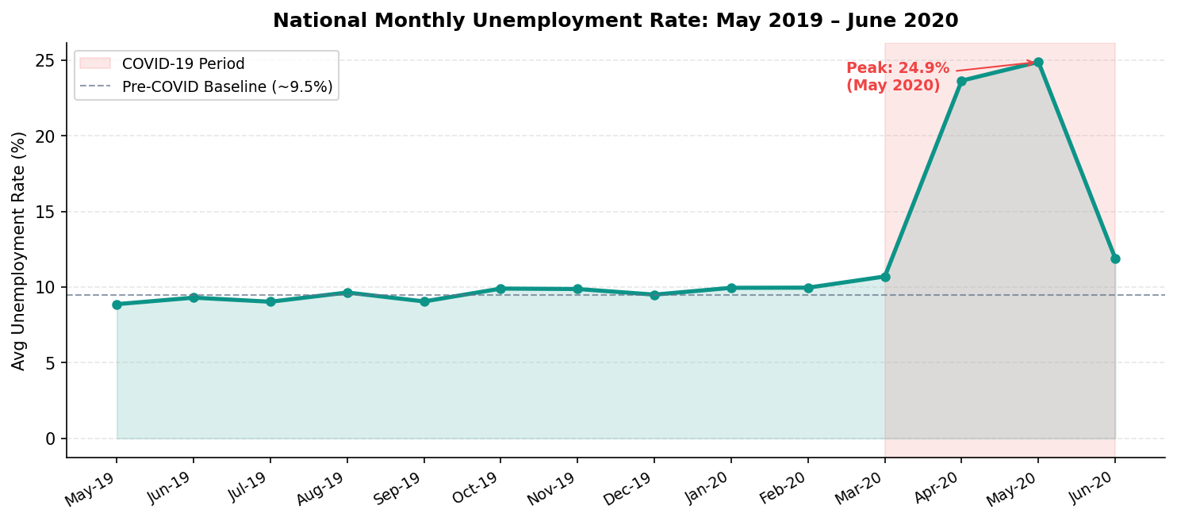
Figure 1: National Average Monthly Unemployment Rate, May 2019 – June 2020

Phase 1 — Pre-COVID Baseline (May 2019 – February 2020)
During the ten months prior to the pandemic's impact on the labour market, the national unemployment rate was remarkably stable, oscillating between 8.87% (May 2019) and 9.96% (February 2020). The mean for this period was 9.51% with a standard deviation of just 0.4 percentage points, confirming the baseline as a tightly bounded normal operational range for the Indian labour market. There is a modest but consistent upward drift across Q4 2019 and into early 2020, which may reflect typical seasonal patterns (discussed in Section 7).

Phase 2 — COVID-19 Shock (March 2020 – May 2020)
The inflection begins in March 2020, when the unemployment rate rose to 10.70% — still only modestly above baseline. The magnitude of disruption became fully apparent in April 2020, when unemployment surged to 23.64%, representing an absolute increase of 12.94 percentage points from February. May 2020 marked the peak of the crisis at 24.88% — an increase of 162% over the pre-COVID mean of 9.51%. This extraordinary spike reflects the comprehensive economic disruption caused by India's nationwide lockdown, which came into force on March 24, 2020, forcing the closure of non-essential businesses, halting construction and manufacturing, and grounding the transportation sector.

Phase 3 — Early Recovery (June 2020)
The initial easing of lockdown restrictions in June 2020 produced a rapid partial recovery. The national unemployment rate fell sharply to 11.90% — a decline of 12.98 percentage points in a single month. While this figure remained 25% above the pre-COVID baseline, the speed and magnitude of the recovery signal the resilience of India's large informal sector, where workers were able to quickly return to economic activity once movement restrictions were relaxed.

4.2 Key Trend Metrics

9.51%  Pre-COVID Baseline | 24.88%  COVID Peak (May 2020) | +162%  Surge Above Baseline | 11.90%  Jun 2020 Recovery

5. Regional Analysis
India's labour market is deeply heterogeneous, shaped by geography, industrial composition, demographic structure, and governance quality. This section analyses average unemployment rates at the state level across the full dataset period, enabling identification of structurally high-risk and resilient regions.

5.1 State-Level Unemployment Rankings
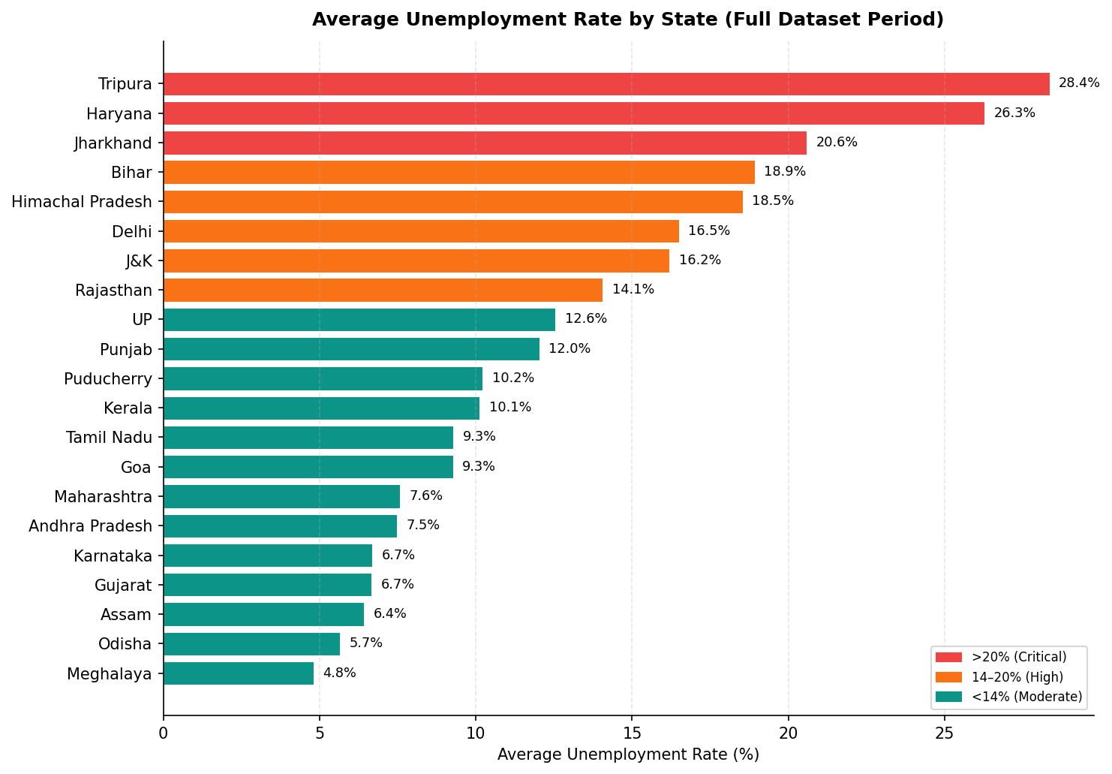
Figure 2: Average Unemployment Rate by State (May 2019 – June 2020)

5.2 Highest Unemployment States
The following states recorded the highest average unemployment rates across the dataset period, indicating structural economic challenges that pre-date and are compounded by COVID-19:

Rank | State | Avg Unemployment Rate (%) | Classification
1 | Tripura | 28.35% | Critical
2 | Haryana | 26.28% | Critical
3 | Jharkhand | 20.58% | Critical
4 | Bihar | 18.92% | High
5 | Himachal Pradesh | 18.54% | High
6 | Delhi | 16.50% | High
7 | Jammu & Kashmir | 16.19% | High
8 | Rajasthan | 14.06% | High
9 | Uttar Pradesh | 12.55% | Elevated
10 | Punjab | 12.03% | Elevated

Tripura's exceptionally high rate (28.35%) reflects the state's limited industrial base, high youth population, and dependence on government employment. Haryana's high rate (26.28%) is particularly striking given its relatively developed economy, suggesting significant structural unemployment driven by agricultural mechanisation and an industrial sector skewed toward large, capital-intensive enterprises with limited labour absorption capacity.

5.3 Lowest Unemployment States

Rank | State | Avg Unemployment Rate (%) | Key Economic Characteristics
1 | Meghalaya | 4.80% | Services, agriculture, mining — high LFPR
2 | Odisha | 5.66% | Agriculture, manufacturing, steel industry
3 | Assam | 6.43% | Tea, agriculture, oil — diverse economy
4 | Uttarakhand | 6.58% | Tourism, horticulture, small industries
5 | Gujarat | 6.66% | Strong manufacturing & industrial base
6 | Karnataka | 6.68% | IT sector, diverse services economy

The lowest-unemployment states share several characteristics: diversified economic bases, strong agricultural sectors that absorb large informal workforces, and in several cases (Gujarat, Karnataka) established industrial or technology sectors that provide stable formal employment.

5.4 Urban vs Rural Unemployment
Across the full dataset, urban areas consistently recorded higher unemployment than rural areas. The average urban unemployment rate of 13.17% exceeded the rural rate of 10.32% by 2.85 percentage points — a difference of approximately 28%.
This urban-rural gap reflects several structural factors. Urban employment is more concentrated in formal-sector services, construction, and retail — sectors that are highly vulnerable to demand shocks and regulatory disruptions. Rural employment is predominantly informal and agricultural, which — while less lucrative — proved more resilient during the lockdown as food production was designated an essential activity and was largely exempt from closure orders.

6. COVID-19 Impact Analysis
The COVID-19 pandemic represents the most severe external shock to India's labour market in recent history. This section isolates and quantifies the pandemic's impact through a comparative phase analysis and timeline reconstruction.

6.1 COVID-19 Timeline

Date | Event | Labour Market Impact
January 30, 2020 | India reports its first confirmed COVID-19 case | Limited immediate impact; markets relatively stable
March 24, 2020 | National lockdown announced (21 days, later extended) | Non-essential businesses closed; workers stranded
April 2020 | Lockdown extended through April 30 | Unemployment spikes to 23.64%
May 2020 | Partial relaxations begin (Lockdown 3.0 & 4.0) | Unemployment peaks at 24.88%
June 2020 | Significant easing; most states move to Unlock 1.0 | Unemployment falls to 11.90% — partial recovery

6.2 Phase Comparison
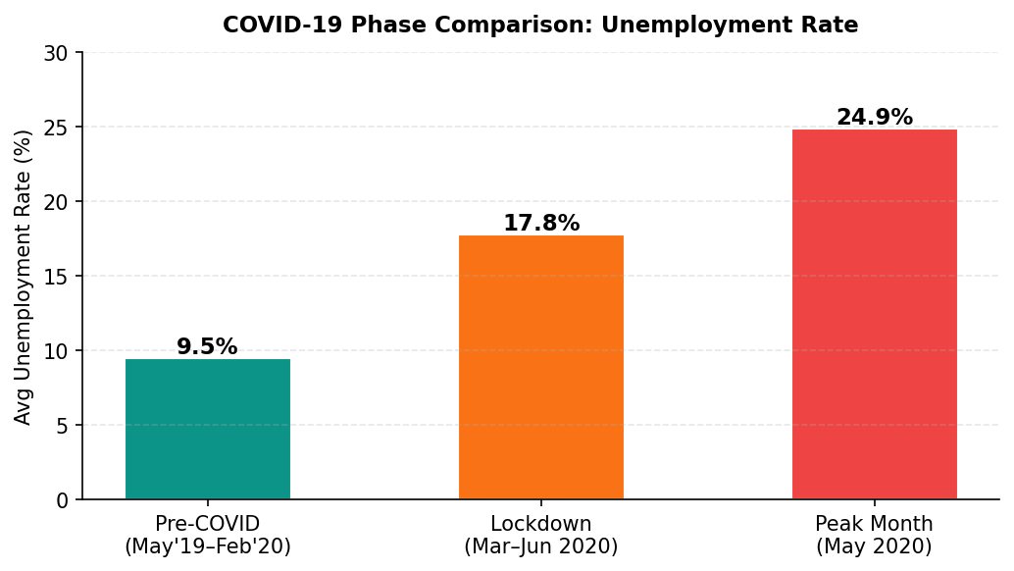
Figure 3: Unemployment Rate by COVID-19 Phase
The three-phase comparison in Figure 3 starkly illustrates the scale of the COVID-19 shock. The lockdown phase average (17.77%) includes the recovery dip in June 2020; when isolated to the two peak months of April and May, the average reaches 24.26% — nearly 2.6 times the pre-COVID baseline.

6.3 Sectoral Impact Analysis
While the dataset does not provide sector-level decomposition, the magnitude and pattern of unemployment across states allows inference about sectoral impact:
- Construction and informal urban labour: The most immediately impacted sector, accounting for the bulk of the April-May unemployment spike. Construction employs approximately 55 million workers in India and came to a near-complete halt during lockdown.
- Manufacturing (non-essential): Automotive, textiles, and consumer goods manufacturing experienced complete shutdowns, displacing millions in industrial corridors of Maharashtra, Gujarat, and Tamil Nadu.
- Retail and trade: The closure of all non-essential retail created immediate unemployment among shop workers, hawkers, and supply chain workers — a predominantly urban informal workforce.
- Agriculture: Largely exempt from lockdown restrictions, agriculture served as a partial employment buffer, particularly as migrant workers returned to rural areas. Rural unemployment remained comparatively lower throughout.
- IT and formal services: Less impacted due to the ability to transition to remote work, contributing to the relative resilience of states like Karnataka (Bengaluru) and parts of Maharashtra.

6.4 Recovery Velocity
The drop from 24.88% in May to 11.90% in June 2020 — a decline of 12.98 percentage points in a single month — represents one of the fastest recorded labour market recoveries in any major economy during the COVID-19 pandemic. This velocity is explained by the dominance of India's informal sector: informal workers, once permitted to return to work, did so immediately without the hiring lag typical of formal employment recovery. However, it is important to note that "recovery" in the informal sector often means return to the same precarious, low-wage work rather than structural improvement in employment quality.
7. Seasonal Trend Analysis
Unemployment rates are influenced by seasonal factors — agricultural harvest cycles, festival-related commerce, construction activity patterns, and academic calendars all create predictable fluctuations in labour demand. This section isolates seasonal patterns by averaging rates across corresponding months.

7.1 Monthly Seasonal Pattern
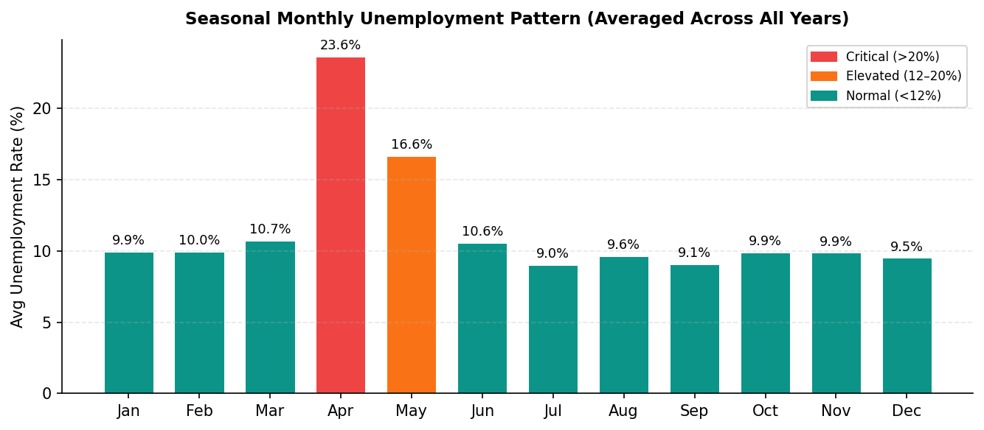
Figure 4: Seasonal Monthly Unemployment Pattern (Averaged Across Dataset Period)
NOTE: Because the dataset spans only 14 months (May 2019 – June 2020), each month appears at most twice in the averages; April and May averages are heavily influenced by the COVID-19 spike. The patterns below should therefore be interpreted as COVID-influenced seasonal signals rather than multi-year normal seasonality.

7.2 Monthly Breakdown

Month | Avg Rate (%) | Status | Key Drivers
January | 9.95% | Normal | Post-harvest slowdown; winter construction pause
February | 9.96% | Normal | Pre-summer baseline; relatively stable
March | 10.70% | Normal→Elevated | COVID-19 lockdown begins late March
April | 23.64% | Critical | Full lockdown impact; construction/retail closed
May | 16.65% | High | Lockdown extended; partial relaxation late May
June | 10.55% | Normal | Unlock 1.0; monsoon agricultural activity ramps
July | 9.03% | Normal | Monsoon season; agricultural labour absorption
August | 9.64% | Normal | Mid-monsoon; consistent with July baseline
September | 9.05% | Normal | Late monsoon; pre-harvest activity
October | 9.90% | Normal | Festival season; retail and commerce uptick
November | 9.87% | Normal | Post-Diwali; construction season resumes
December | 9.50% | Normal | Year-end; slight seasonal softening

7.3 Seasonal Observations
- Pre-COVID seasonality (Jul–Feb): Unemployment remains tightly bounded between 9.0% and 10.0%, suggesting a natural seasonal floor driven by India's diverse economic calendar. The monsoon months (July–September) show the lowest rates, consistent with high agricultural labour absorption during the kharif crop growing season.
- Festival season effect (October–November): The slight uptick to ~9.9% during October-November may seem counterintuitive but reflects the seasonal entry of additional workers into the labour force seeking festival-period income — an increase in labour supply that marginally outpaces demand growth.
- COVID distortion (April–May): The April (23.64%) and May (16.65%) seasonal averages are entirely COVID-dominated and should not be treated as representative of normal April-May patterns.
- Q1 pattern (January–March): The Jan-Feb period shows the highest non-COVID baseline rates (~9.95%), consistent with a post-harvest lull and the pre-monsoon lean season for agricultural states.

8. Labour Force Participation Rate Analysis
The Labour Force Participation Rate (LFPR) measures the percentage of the working-age population (15 years and above) that is actively participating in the labour force — either employed or actively seeking employment. The LFPR provides critical context for interpreting unemployment figures, as low unemployment can mask low participation (i.e., many people have given up looking for work).

8.1 National LFPR Overview
The national average LFPR in the dataset is 42.63%, with a standard deviation of 8.11%. This places India significantly below global averages; for comparison, OECD countries typically report LFPRs in the 60–75% range. India's relatively low LFPR reflects several structural factors: low female labour force participation (particularly in conservative northern states), large student and homemaker populations, and a significant share of discouraged workers — those who have abandoned job-seeking due to perceived futility.

8.2 State-Level LFPR
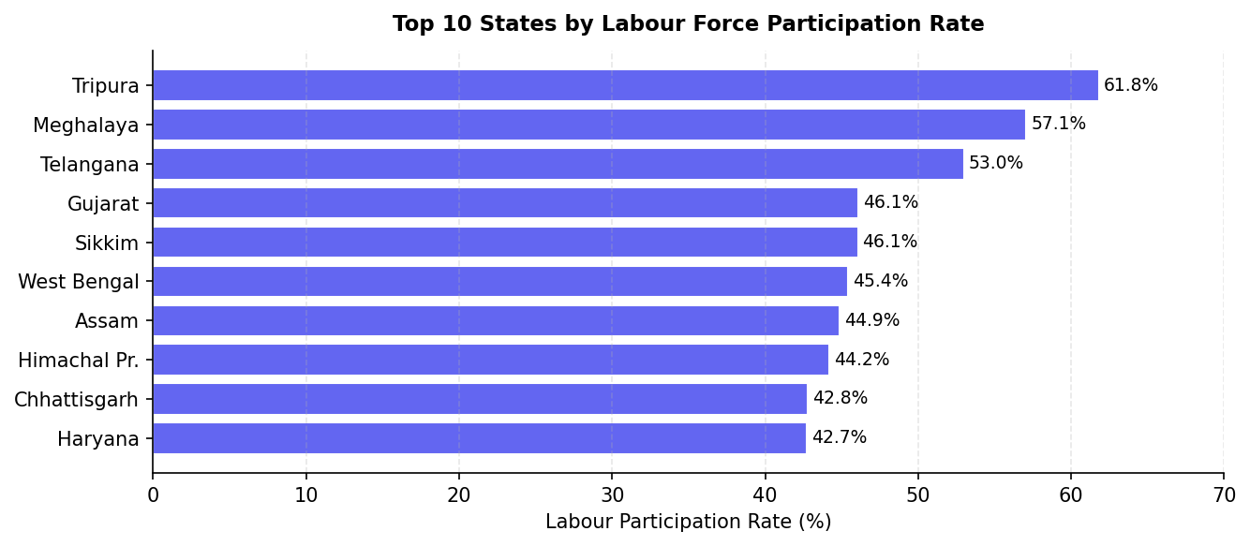
Figure 5: Top 10 States by Labour Force Participation Rate

State | LFPR (%) | Unemployment Rate (%) | Interpretation
Tripura | 61.82% | 28.35% | High participation + high unemployment = labour surplus
Meghalaya | 57.08% | 4.80% | High participation + low unemployment = efficient market
Telangana | 53.00% | 7.74% | High participation + moderate unemployment = healthy
Gujarat | 46.10% | 6.66% | Good participation + low unemployment = strong market
West Bengal | 45.42% | 8.12% | Moderate participation, moderate unemployment
Kerala | 34.87% | 10.12% | Low participation + elevated unemployment = discouraged workers
Uttarakhand | 33.78% | 6.58% | Low participation + low unemployment = selective workforce

8.3 The Labour Participation Paradox
A striking finding emerges when cross-tabulating LFPR and unemployment rates: some states with very high labour force participation also exhibit very high unemployment (Tripura: 61.82% LFPR, 28.35% unemployment), while other states combine low LFPR with low unemployment (Uttarakhand: 33.78% LFPR, 6.58% unemployment).
This apparent paradox reflects two distinct labour market failure modes. In Tripura's case, a large working-age population actively seeks employment, but the state's limited industrial capacity cannot absorb this supply — creating structural unemployment. In Uttarakhand's case, the low LFPR may mask discouraged workers who have exited the labour force after failing to find employment, artificially depressing the measured unemployment rate.
Kerala presents a different dimension: its relatively low LFPR (34.87%) combined with elevated unemployment (10.12%) and its status as a major source of Gulf migrant workers suggests a population that sees emigration as a primary employment pathway, lowering domestic participation but not necessarily employment outcomes overall.
9. Key Insights
The following insights represent the most analytically significant findings from this comprehensive examination of Indian unemployment data:

Insight 1: COVID-19 Caused a Historic, Unprecedented Labour Market Shock
India's national lockdown triggered one of the sharpest labour market deteriorations in modern economic history. The 162% surge in unemployment from a stable ~9.5% baseline to a peak of 24.9% — occurring over just two months — has no comparable precedent in India's post-liberalisation economic record. The lockdown's comprehensiveness, speed of implementation, and application to both urban and rural economies simultaneously amplified its labour market impact beyond what was observed in most other countries.

Insight 2: Geographic Concentration of Vulnerability
Unemployment risk is geographically concentrated in India. The top five high-unemployment states (Tripura, Haryana, Jharkhand, Bihar, Himachal Pradesh) account for a disproportionate share of the aggregate employment problem. These states share characteristics including limited industrial diversification, large agricultural workforces vulnerable to mechanisation-driven displacement, and significant youth populations entering a labour market with inadequate formal job creation.

Insight 3: Urban-Rural Divide in Vulnerability and Recovery
Urban areas consistently recorded higher unemployment (13.17% average) than rural areas (10.32%), driven by their concentration of formal-sector services, retail, and construction. However, the urban-rural gap likely understates the true difference in labour market distress: rural informal workers who are 'employed' in subsistence agriculture may earn well below subsistence wages, while urban unemployment measures capture workers who have actively sought formal employment and not found it.

Insight 4: India's Informal Sector as Economic Shock Absorber
The extraordinary speed of partial recovery in June 2020 — a 12.98 percentage point fall in a single month — demonstrates the unique resilience properties of India's large informal sector. Informal workers do not require re-hiring processes, background checks, or formal contracts; they simply return to pre-existing activities when movement restrictions ease. This resilience is a double-edged characteristic: it enables rapid recovery but also means that 'employment' does not necessarily imply adequate income, social protection, or job quality.

Insight 5: The Labour Participation Paradox Signals Structural Issues
The divergence between LFPR and unemployment across states — particularly the high-participation-high-unemployment combination in Tripura — signals structural labour market failures that cannot be addressed by demand-side stimulus alone. States with abundant but unemployed labour forces require supply-side interventions: skills development, industrial diversification, infrastructure investment, and policies to attract private sector investment into underserved regional economies.

Insight 6: Seasonal Stability Provides a Reliable Policy Benchmark
The tight pre-COVID seasonal band (9.0–10.0%) provides a reliable empirical benchmark against which future policy interventions can be measured. A post-pandemic 'return to baseline' of approximately 9.5% represents a minimum policy target; more ambitious targets should aim for structural reduction below this baseline through formalisation of employment relationships, skills development, and industrial deepening.
10. Policy Recommendations
Based on the analytical findings presented in this report, the following six evidence-based recommendations are proposed for consideration by policymakers, economic development authorities, and crisis preparedness planners:

Recommendation 1: State-Targeted Economic Stimulus
Priority economic stimulus should be directed to the five highest-unemployment states: Tripura, Haryana, Jharkhand, Bihar, and Himachal Pradesh. Generic national stimulus packages dilute resources across states with divergent needs; targeted interventions calibrated to the structural drivers of unemployment in each state will produce superior outcomes per rupee of public expenditure.
- Tripura: Invest in IT/digital services infrastructure and agri-processing industries to create non-agricultural formal employment pathways.
- Haryana: Expand MSME support and vocational training aligned with the state's industrial corridors, particularly in auto components, food processing, and logistics.
- Jharkhand & Bihar: Accelerate infrastructure investment (roads, irrigation, rural electrification) as a direct employment generator with long-term productivity co-benefits.

Recommendation 2: Urban Safety Net Expansion
The consistently higher urban unemployment rate (13.17%) and the concentration of formal-sector job losses in urban areas during COVID-19 underscores the need for strengthened urban social protection. India's existing safety net architecture (MGNREGS, PDS) is predominantly rural-oriented; an equivalent urban employment guarantee programme should be developed and implemented, with digital-first registration enabling rapid deployment during future crises.

Recommendation 3: Labour Force Participation Enhancement for Women
India's aggregate LFPR of 42.63% is held down significantly by low female LFPR, particularly in northern states. Structural interventions targeting women's labour market participation — childcare infrastructure, safe transportation, anti-discrimination enforcement, and targeted skill development for female workers — would simultaneously address unemployment and expand the productive labour force available to the economy.

Recommendation 4: Strengthening Rural Employment Buffers
The MGNREGA (Mahatma Gandhi National Rural Employment Guarantee Act) functioned as a partial automatic stabiliser during the COVID-19 crisis, absorbing returning migrant workers in rural areas. Strengthening MGNREGA by increasing wage rates to current market levels, expanding coverage to include skilled work categories, and improving payment timeliness would enhance its effectiveness as a crisis buffer and reduce seasonal rural unemployment.

Recommendation 5: Real-Time Labour Market Monitoring Infrastructure
This analysis was possible because of CMIE's high-quality monthly state-level data. Investing in continuous, district-level labour market data collection — with near-real-time dashboards accessible to policymakers — would enable earlier identification of emerging employment crises and more targeted, timely policy responses. The gap between the March 24 lockdown announcement and available employment data (April 30 month-end) represents a critical four-week blind spot; higher-frequency data collection would close this gap.

Recommendation 6: Crisis Employment Preparedness Framework
India should develop and pre-approve a crisis employment protocol — analogous to central bank emergency liquidity facilities — that can be activated within 72 hours of a declared economic emergency. This framework should include: immediate direct transfer triggers for workers in affected sectors, sector-specific support packages (construction, retail, hospitality) calibrated to actual employment exposure, and pre-negotiated partnerships with state governments for rapid benefit distribution. The COVID-19 experience demonstrated that the lag between crisis onset and government response cost millions of workers weeks of income; preparedness can dramatically reduce this lag in future events.
11. Conclusion
This report has presented a detailed, multi-dimensional analysis of unemployment in India using monthly CMIE data covering 28 states and union territories from May 2019 to June 2020. The analysis encompasses temporal trend analysis, regional benchmarking, COVID-19 impact quantification, seasonal pattern decomposition, and labour force participation examination — producing a comprehensive picture of India's labour market dynamics during one of its most turbulent periods.
The central finding is unambiguous: the COVID-19 national lockdown inflicted a historic shock on India's labour market, raising the national unemployment rate from a stable 9.51% baseline to a peak of 24.88% in just two months — a 162% surge without modern precedent in the Indian economy. The subsequent rapid partial recovery to 11.90% in June 2020 demonstrates both the resilience of India's informal sector and the inadequacy of that resilience as a substitute for formal social protection.
Beyond the pandemic shock, the analysis surfaces important pre-existing structural vulnerabilities: the concentration of chronic unemployment in specific northern and eastern states, the persistent urban-rural gap in employment outcomes, and the labour participation paradox that complicates simple unemployment-rate interpretations. These structural issues will persist beyond COVID-19 recovery and require sustained policy attention.
The six recommendations proposed in this report — from targeted state-level stimulus to crisis preparedness frameworks — are evidence-based, implementable, and calibrated to the specific findings of this analysis. They represent a starting point for data-driven labour market policy rather than an exhaustive programme; their effectiveness should be evaluated through the same kind of rigorous, data-driven monitoring that this report exemplifies.
Data science, applied to questions of this societal significance, can translate large datasets into actionable policy intelligence. The availability of CMIE's labour market data enables exactly this kind of evidence-based decision-making — an approach that should be institutionalised as a cornerstone of India's policy development process.

Report prepared: June 2026 | Dataset: CMIE Unemployment in India | Source: https://unemploymentinindia.cmie.com/
Appendix A: Complete Regional Unemployment Data
The following table presents the full state-level average unemployment and labour participation rate data used throughout this report, sorted by average unemployment rate (descending):

Rank | State / UT | Avg Unemployment (%) | Avg LFPR (%) | Unemployment Tier
1 | Tripura | 28.35% | 61.82% | Critical (>20%)
2 | Haryana | 26.28% | 42.74% | Critical (>20%)
3 | Jharkhand | 20.58% | 41.67% | Critical (>20%)
4 | Bihar | 18.92% | 38.15% | High (15–20%)
5 | Himachal Pradesh | 18.54% | 44.22% | High (15–20%)
6 | Delhi | 16.50% | 38.93% | High (15–20%)
7 | Jammu & Kashmir | 16.19% | 41.03% | High (15–20%)
8 | Chandigarh | 15.99% | 39.34% | High (15–20%)
9 | Rajasthan | 14.06% | 39.97% | Elevated (10–15%)
10 | Uttar Pradesh | 12.55% | 39.43% | Elevated (10–15%)
11 | Punjab | 12.03% | 41.14% | Elevated (10–15%)
12 | Puducherry | 10.22% | 38.99% | Elevated (10–15%)
13 | Kerala | 10.12% | 34.87% | Elevated (10–15%)
14 | Tamil Nadu | 9.28% | 40.87% | Moderate (5–10%)
15 | Goa | 9.27% | 39.25% | Moderate (5–10%)
16 | Chhattisgarh | 9.24% | 42.81% | Moderate (5–10%)
17 | West Bengal | 8.12% | 45.42% | Moderate (5–10%)
18 | Telangana | 7.74% | 53.00% | Moderate (5–10%)
19 | Maharashtra | 7.56% | 42.30% | Moderate (5–10%)
20 | Andhra Pradesh | 7.48% | 39.38% | Moderate (5–10%)
21 | Madhya Pradesh | 7.41% | 38.82% | Moderate (5–10%)
22 | Sikkim | 7.25% | 46.07% | Moderate (5–10%)
23 | Karnataka | 6.68% | 41.35% | Low (<7%)
24 | Gujarat | 6.66% | 46.10% | Low (<7%)
25 | Uttarakhand | 6.58% | 33.78% | Low (<7%)
26 | Assam | 6.43% | 44.87% | Low (<7%)
27 | Odisha | 5.66% | 38.93% | Low (<7%)
28 | Meghalaya | 4.80% | 57.08% | Low (<7%)

Appendix B: Data Cleaning Python Code
The following Python code was used for data loading and cleaning:
import pandas as pd

# Load dataset
df = pd.read_csv('Unemployment_in_India.csv')

# Step 1 & 2: Detect and remove null rows
print('Null counts before cleaning:')
print(df.isnull().sum())
df_clean = df.dropna()
print(f'Rows removed: {len(df) - len(df_clean)}')

# Step 3: Standardise column names
df_clean.columns = [c.strip() for c in df_clean.columns]

# Step 4: Parse date column
df_clean['Date'] = pd.to_datetime(
df_clean['Date'].str.strip(), format='%d-%m-%Y'
)

# Step 5: Validate types
print(df_clean.dtypes)

# Step 6: Check for duplicates
dupes = df_clean.duplicated(subset=['Region','Date','Area']).sum()
print(f'Duplicate records: {dupes}')

print(f'Final shape: {df_clean.shape}')
print(df_clean.describe())

